Sheldon Christian School Hot Lunch Menu
October 2021

October 1- Mr. Rib, curly fries, fruit, milk

October 4 - Popcorn chicken, green beans, pears, milk
October 5: Scalloped Potatoes & ham, veg tray, fresh fruit, milk
October 6: Spaghetti, lettuce, fresh fruit, milk, breadstick
October 7: No School
October 8: No School

October 11: Sack Lunch – Cooks are going to school!
October 12: Stromboli, veg tray, fresh fruit, milk
October 13: Tacos, rice, fresh fruit, milk
October 14: Subs/Turkey club, chips, frozen fruit cup, milk
October 15: Chicken strips, waffle fries, pineapple, milk

October 18: Fish Sticks, corn, peaches, milk
October 19: Chicken noodle hot dish, veg tray, fresh fruit, milk
October 20: Tavern, tater tots, fresh fruit, milk
October 21: 7th grade menu – Orange chicken & Rice, Apples w/ Caramel, milk, strawberry salad, peach delight.
October 22: Pizza, lettuce, fruit, milk

October 25: Breakfast pizza, hashbrown, pears, milk
October 26: Super Nachos, refined beans, fruit, milk
October 27: Chicken /chili soup, veg tray, fresh fruit, milk, cinnamon roll
October 29: Pulled Pork, JoJo’s, fruit, milk
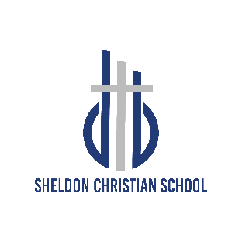
Sheldon Christian School prepares God’s children for a lifetime of kingdom service by providing quality God-Centered education.

Iowa Non-Discrimination Statement: “It is the policy of this CNP provider not to discriminate on the basis of race, creed, color, sex, sexual orientation, gender identity, national origin, disability, age, or religion in its programs, activities, or employment practices as required by the Iowa Code section 216.6, 216.7, and 216.9. If you have questions or grievances related to compliance with this policy by this CNP Provider, please contact the Iowa Civil Rights Commission, Grimes State Office building, 400 E. 14th St. Des Moines, IA 50319-1004; phone number 515- 281-4121, 800-457-4416; website: https://icrc.iowa.gov/.”

